Project Design Phase-II
Data Flow Diagram & User Stories
Date | 27 February 2026
Team ID | LTVIP2026TMIDS66231
Project Name | IntelliSQL: Intelligent SQL Querying with LLMs using Gemini Pro
Maximum Marks | 4 marks

Data Flow Diagrams:
The IntelliSQL System is designed to enable intelligent, natural language-driven SQL querying using Large Language Models (LLMs) powered by Gemini Pro. The system begins with user query inputs, which include natural language questions, database schema context, user credentials, and query preferences. This data is processed by the LLM Query Engine, which serves as the central component for translating natural language to SQL, executing queries, and returning structured results to the user.
Flow Diagram:
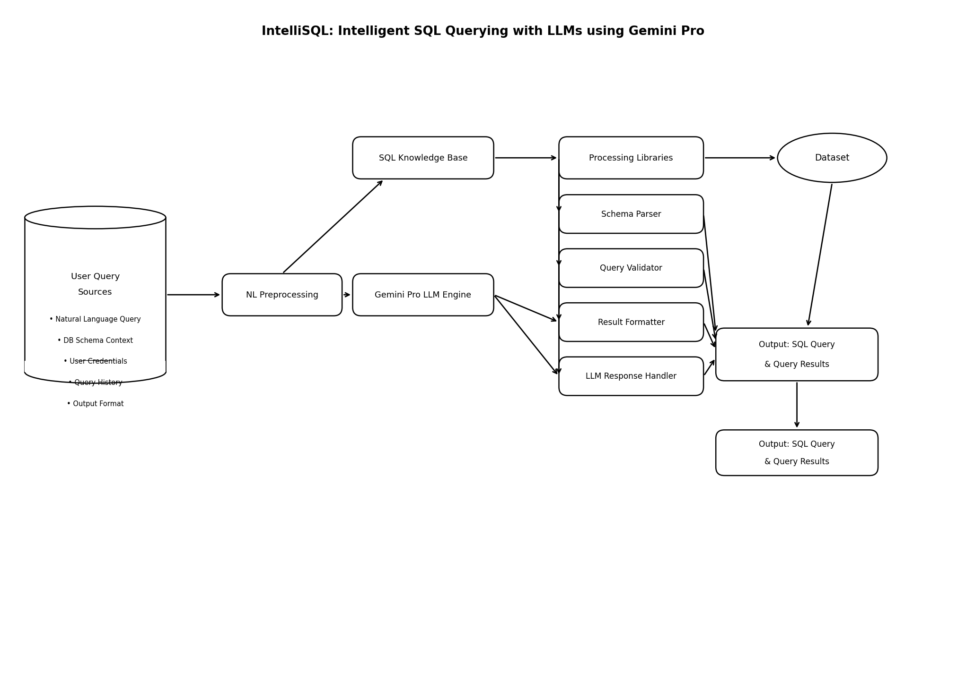
User Stories
Use the below template to list all the user stories for the product.
User Type | Functional Requirement (Epic) | User Story Number | User Story / Task | Acceptance Criteria | Priority | Release
Data Analyst | Natural Language Query Input | USN-1 | As a Data Analyst, I want to enter natural language queries so that the system converts them to SQL and retrieves accurate results from the database. | System allows artifact upload with name, mission, description, and images. Data is stored securely. Upload completes successfully without errors. | High | Sprint-1
Business User | SQL Query Generation and Access | USN-2 | As a Business User, I want to search and retrieve database records using plain English so that I can access data insights without writing SQL manually. | System provides accurate artifact search results. Artifact details and images are displayed clearly. Search results load within 3 seconds. | High | Sprint-1
Student / Public User | Query Results Viewing | USN-3 | As a Student, I want to view query results and generated SQL so that I can learn how natural language maps to database queries. | Artifact information is displayed clearly. Images and mission details are accessible. System provides easy navigation. | Medium | Sprint-2
System Administrator | Database Schema Management | USN-4 | As an Administrator, I want to manage artifact records so that the system remains accurate and secure. | Admin can add, edit, and delete artifact records. System maintains data integrity. Unauthorized access is restricted. | High | Sprint-1
Database Administrator | Query History and Documentation | USN-5 | As a Database Administrator, I want to document query history and present | System allows preservation status updates. | High | Sprint-2

